EXP : 5 DATE : 18.08.2026
DESIGN AND SIMULATION OF COMMON BASE AMPLIFIER USING LTSPICE SIMULATOR

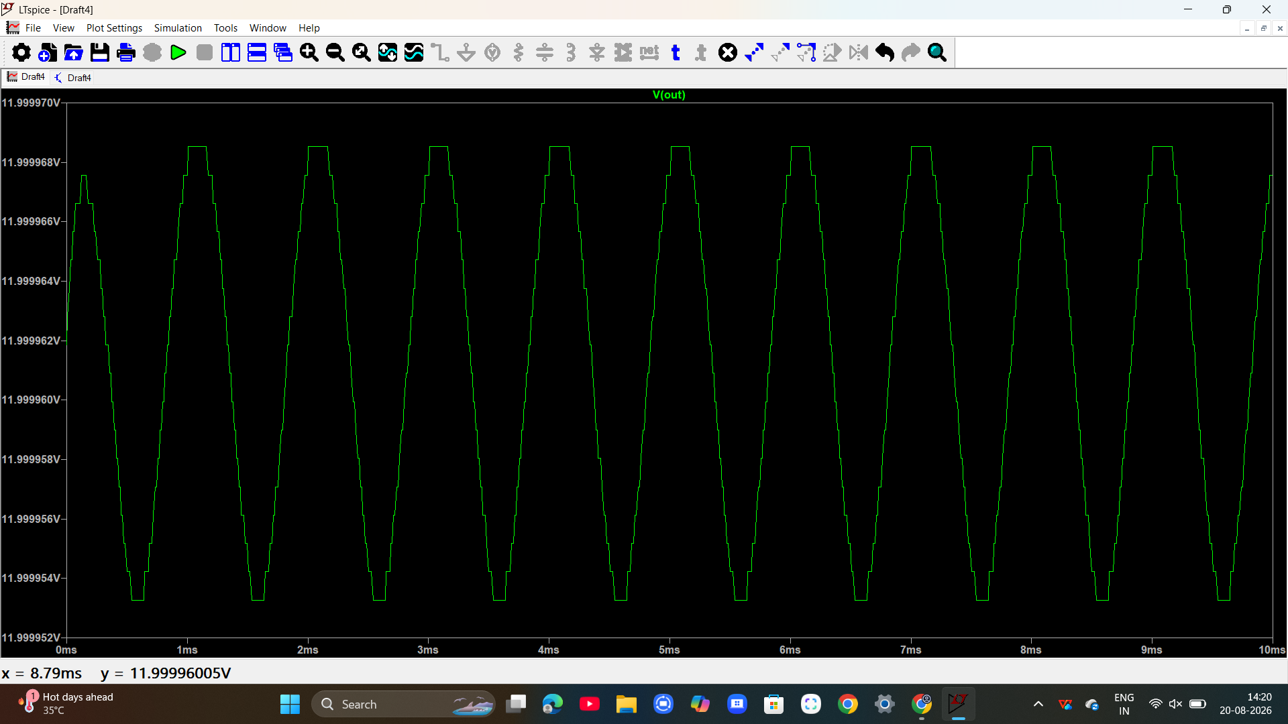

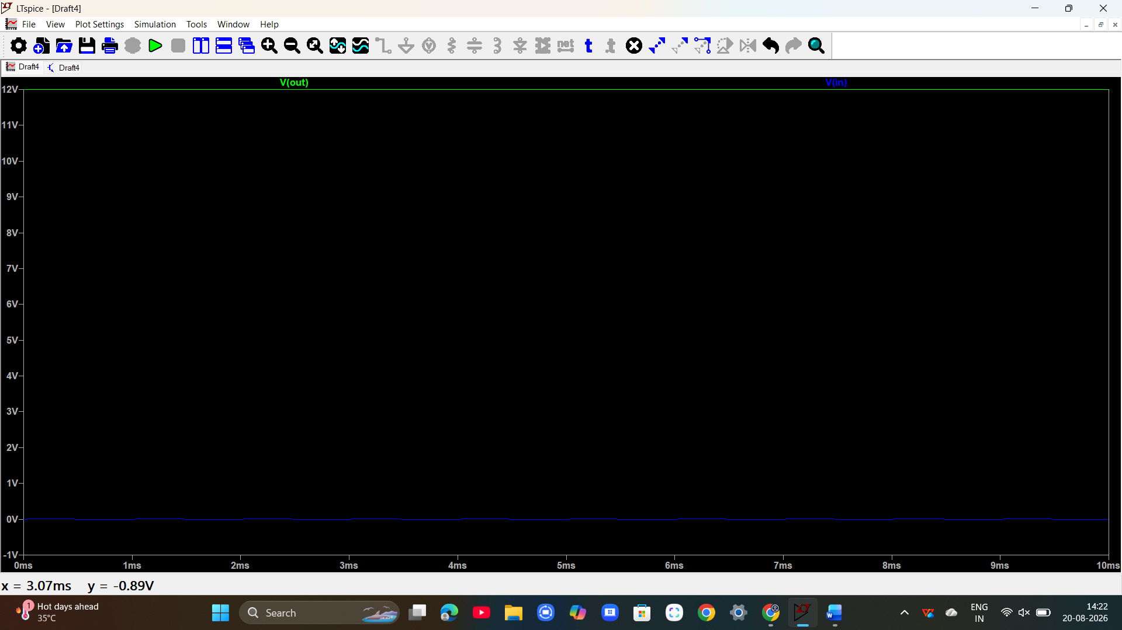

EXP : 7 DATE : 18.8.2026
DESIGN AND SIMULATION OF SCHMITT TRIGGER USING LT SPICE
SIMULATOR
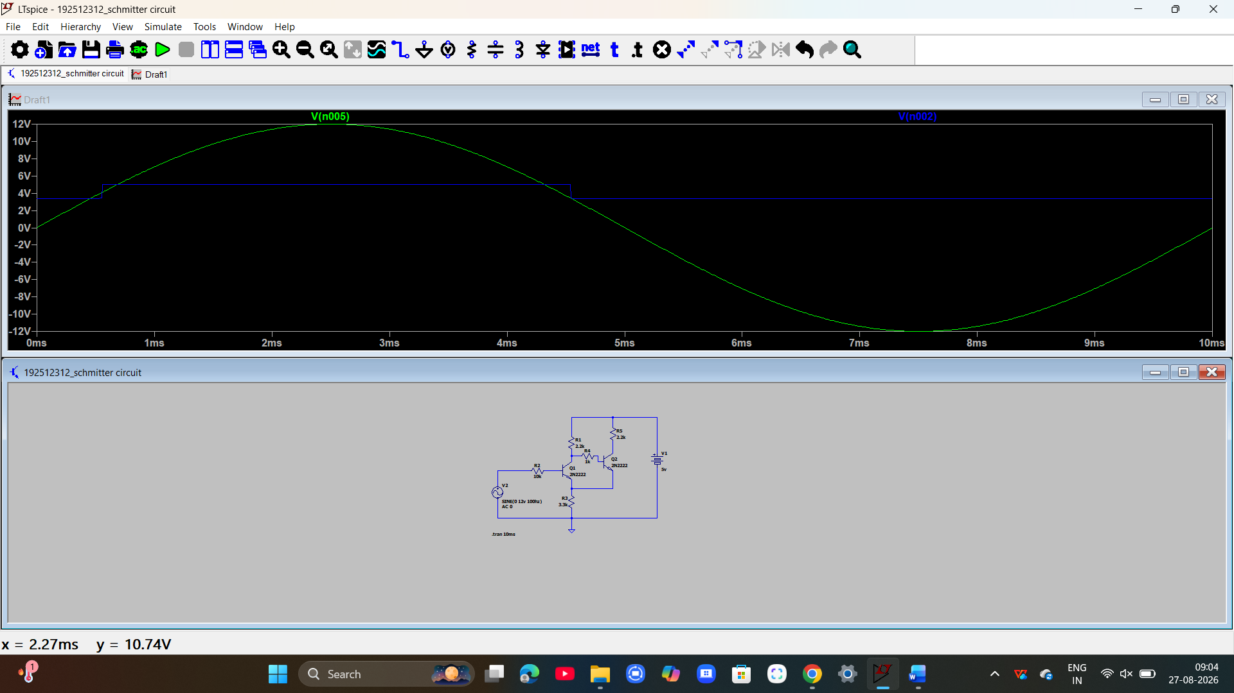

EXP : 6 DATE : 18.9.2026
DESIGN OF ASTABLE MULTIVIBRATOR USING BJT

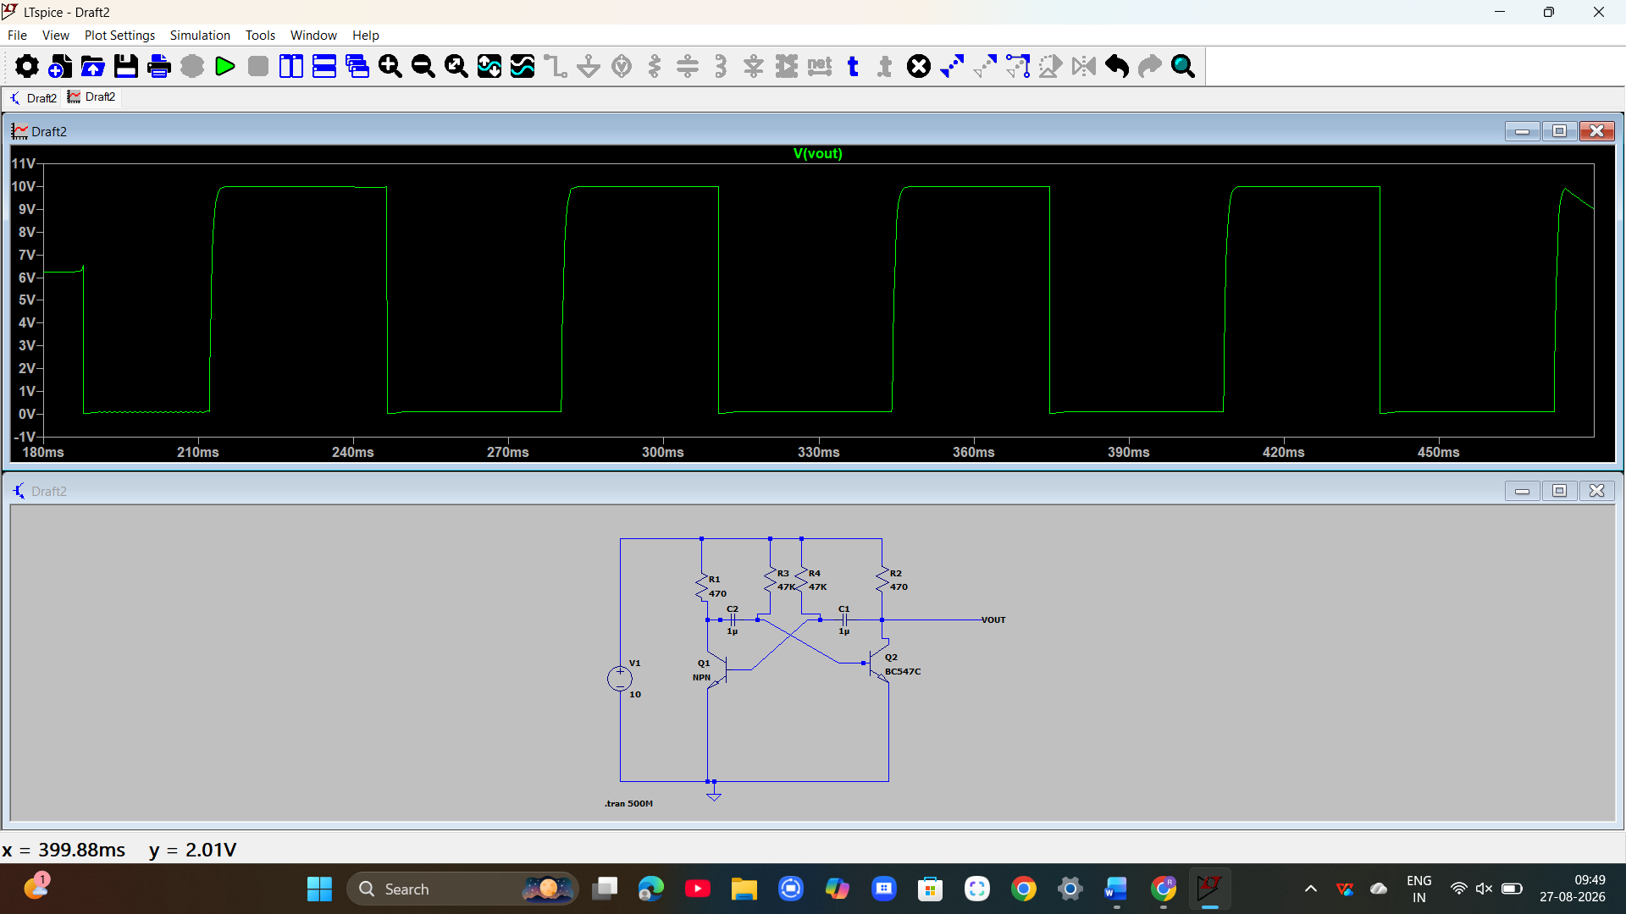

EXP : 8 DATE : 18.9.2026

DESIGN AND SIMULATION OF UJT RELAXATION OSCILLATOR USING
LT SPICE SIMULATOR

